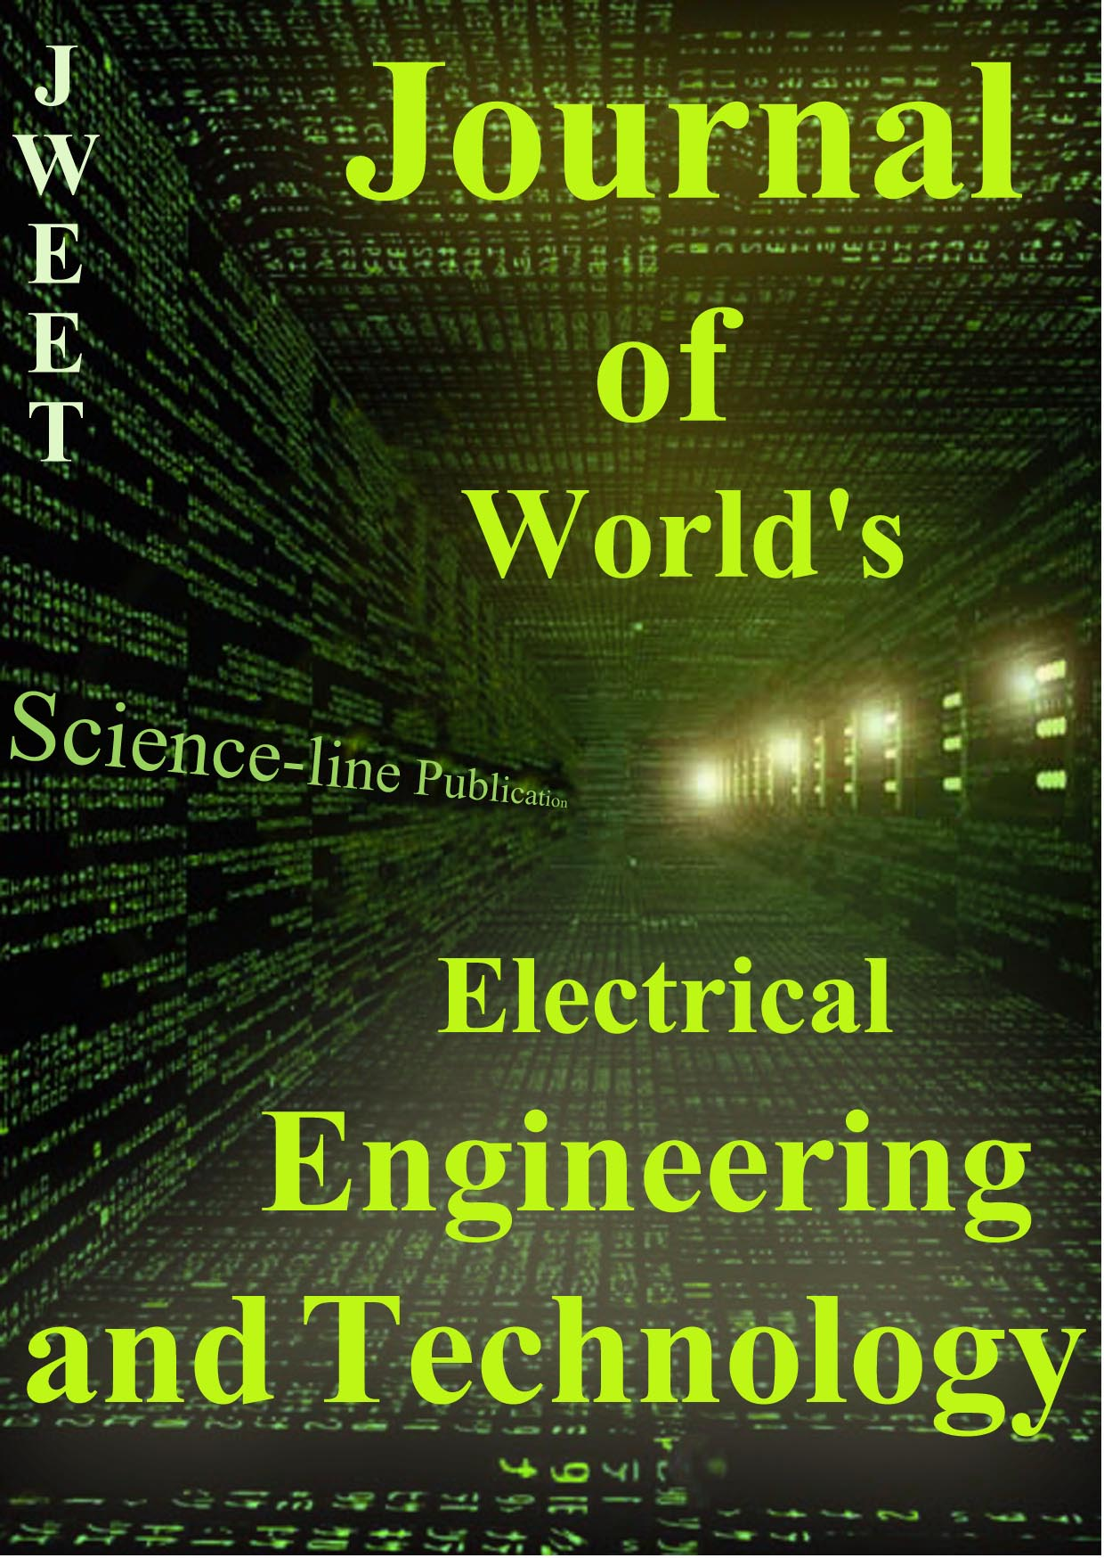 | JWEET ISSN: ‪2322-5114 | Journal of World^{’s} Electrical Engineering and Technology  J. World. Elect. Eng. Tech. 0(0): 00-00, January 25, 2018 | 2018 SCIENCELINE  www.science-line.com

Click

First*
^{1First}
^{2Second}
*Corresponding's Email: author@institute.xxx

Abstract – Delete  This template gives you guidelines and desired layout for final manuscript of Journal of World’s Electrical Engineering and Technology (JWEET). Abstract should not contain any equations, references, or footnotes. This article plays the role of a template as well as the guidelines for prospective authors who will have to prepare the final manuscript accepted for publication by JWEET.  Keywords: 3 | ORIGINAL ARTICLE  PII: S232251141800001-7  Received 00 Aug. 2018  Accepted 00 Sep. 2018

INTRODUCTION
These instructions give you the guidelines to prepare papers for JWEET. Use this document as a template if you are using Microsoft Word 6.0 or later. Otherwise, use this document as an instruction set. The electronic file of your paper will be formatted further at JWEET. Define all symbols used in the abstract. Do not delete the blank line immediately above and below the abstract; it sets the column format.

FORMAT OF MANUSCRIPT
All submitted papers should be formatted to 8.5 × 11 inch (21.6 × 27.9 cm) paper. The suggested length of a regular paper would be 4~10 pages, numbered and in this style. All fonts are Times New Roman.

MAIN TITLE AND AUTHOR AFFILIATION
Each Chapter starts with two line be centered at the top of the page; it has to be Times New Roman 16 pts not typed in capital letter. Leave one line spaces of 10 pts and give the name(s) of the author(s). The font size of the authors is 12 pts. The authors’ affiliation should be written immediately below line of the names in Italic form.

ABSTRACT AND KEYWORDS
Leave one line space of 10 pts and then give the abstract. Before the body of the abstract and the keywords, the terms ‘Abstract -’ and ‘Keywords:’ should come in bold and Italic 10 pts, respectively.
The abstract must be on one column. The phrase of ‘Original Article’ should be remaining on the right side of the page. The abstract should be limited to 70-200 words and should concisely state what was done, how it was done, principal results, and their significance. The abstract will appear later in various abstracts journals and should contain the most critical information of the paper. Skip a line space of 10 pts between the end of the abstract and the keywords.
Keywords are usually composed of about four terms or phrases in alphabetical order, separated by commas. For a list of suggested keywords, you can visit: http://www.ieee.org/organizations/pubs/ani_prod/keywrd98.txt.

BODY
Full-length papers generally consist of introduction, nomenclature, if any, main parts of the body, conclusions. It must be in two column format. The width of each column should be 8.0 cm (3.29 inches). There must be 1 cm spacing between the two columns.
The font sizes of the section headings are bold 11 pts centered and those of the subsection headings italic 10 pts indicating with capital alphabets, respectively. Subsections may as well not exceed further than one-step lower level. Section and subsection headings must be formatted with 18 pts spacing before the headings and 6 pts spacing after the heading. The text body has to be Times New Roman 10 pts, single spaced; flush the first line of each paragraph at 0.4 cm from the left hand margin.
As for the fonts and the sizes of the headings, this manuscript in itself constitutes a good example.

- Tables and Figures
Format and save your graphic images using a suitable graphics processing program that will allow you to create the images as PostScript (PS), Encapsulated PostScript (EPS), or Tagged Image File Format (TIFF), sizes them, and adjusts the resolution settings.
Please insert your figures with “inline wrapping” text style, as in this template (see Fig. 1).
Place figure captions below the figures; place table titles above the tables. Tables and figures must be centered. Large figures and tables may span both columns. If your figure has two parts, include the labels “(a)” and “(b)”. Letters in the figure should be large enough to be readily legible when the drawing is reduced. Use the abbreviation “Fig.” even at the beginning of a sentence. Do not abbreviate “Table.” Tables are numbered with Roman numerals. Please do not include captions as part of the figures. Do not put captions in “text boxes” linked to the figures. Do not put borders around the outside of your figures. The title of the Table must be centered; it has to be 8 pt typed in capital letter. Leave one line space of 10 pt after the Table.
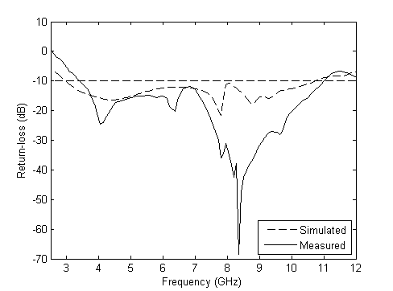
Fig. 1 - Measured and simulated of the proposed antenna. Figure caption must be 8 pt. Leave one line space of 10 pts after the figure caption.

- Abbreviation and Acronyms
Abbreviation and acronyms should be defined the first time they appear in the text, even after the have already been defined in the abstract. Do not use abbreviations in the title unless they are unavoidable.

- Units
It is strongly encouraged that the authors may use SI (International System of Units) units only.

- Equations
Equations should be placed at the center of the line and provided consecutively with equation numbers in parentheses flushed to the right margin, as in (1). You must use Microsoft Equation Editor or Mathtype.
Be sure that the symbols used in your equation have been defined before the equation appears or immediately following. Refer to “(1),” not “Eq. (1)” or “equation (1),” except at the beginning of a sentence: “Equation (1) is ...”
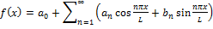 (1)

- References
Number citations consecutively in square brackets [1]. The sentence punctuation follows the brackets [2]. Multiple references [2], [3] are each numbered with separate brackets [1]–[3]. When citing a section in a book, please give the relevant page numbers [2]. In sentences, refer simply to the reference number, as in [3]. Do not use “Ref. [3]” or “reference [3]” except at the beginning of a sentence: “Reference [3] shows ...” Please do not use automatic endnotes in Word, rather, type the reference list at the end of the paper using the “References” style.

TABLE 1
Units for Magnetic Properties
Symbol | Quantity | Conversion from Gaussian and CGS EMU to SI a
Φ | magnetic flux | 1 Mx → 10−8 Wb = 10−8 V·s
B | magnetic flux density,  magnetic induction | 1 G → 10−4 T = 10−4 Wb/m2
H | magnetic field strength | 1 Oe → 103/(4π) A/m
m | magnetic moment | 1 erg/G = 1 emu  → 10−3 A·m2 = 10−3 J/T
M | magnetization | 1 erg/(G·cm3) = 1 emu/cm3  → 103 A/m
4πM | magnetization | 1 G → 103/(4π) A/m
σ | specific magnetization | 1 erg/(G·g) = 1 emu/g  → 1 A·m2/kg
j | magnetic dipole  moment | 1 erg/G = 1 emu  → 4π × 10−10 Wb·m
J | magnetic polarization | 1 erg/(G·cm3) = 1 emu/cm3  → 4π × 10−4 T
χ, κ | susceptibility | 1 → 4π
χρ | mass susceptibility | 1 cm3/g → 4π × 10−3 m3/kg
μ | permeability | 1 → 4π × 10−7 H/m  = 4π × 10−7 Wb/(A·m)
μr | relative permeability | μ → μr
w, W | energy density | 1 erg/cm3 → 10−1 J/m3
N, D | demagnetizing factor | 1 → 1/(4π)
Vertical lines are optional in tables. Statements that serve as captions for the entire table do not need footnote letters.
a Gaussian units are the same as cgs emu for magnetostatics; Mx = maxwell, G = gauss, Oe = oersted; Wb = weber, V = volt, s = second, T = tesla, m = meter, A = ampere, J = joule, kg = kilogram, H = henry.

Number footnotes separately in superscripts (Insert | Footnote). Place the actual footnote at the bottom of the column in which it is cited; do not put footnotes in the reference list (endnotes). Use letters for table footnotes (see Table I).
Please note that the references at the end of this document are in the preferred referencing style. Give all authors’ names; do not use “et al.” unless there are six authors or more. Use a space after authors’ initials. Papers that have not been published should be cited as “unpublished” [4]. Papers that have been accepted for publication, but not yet specified for an issue should be cited as “to be published” [5]. Papers that have been submitted for publication should be cited as “submitted for publication” [6]. Please give affiliations and addresses for private communications [7].
Capitalize only the first word in a paper title, except for proper nouns and element symbols. For papers published in translation journals, please give the English citation first, followed by the original foreign-language citation [8].

CONCLUSION
Even though a conclusion may review the main results or contributions of the paper, do not duplicate the abstract or the introduction. For a conclusion, you might elaborate on the importance of the work or suggest the potential applications and extensions.

Appendix
Appendixes, if needed, appear before the acknowledgment.

Authors’ Contribution (one of the examples)
1- Authors were participated on data collection and gathering information for this paper.
3- F Nabi and MI Rind participated in the design of study. F Nabi and M Zulqarnain performed the experiments, IBM, MK Iqbal analyzed the data. MS and MR critically revised the manuscript for important intellectual contents. F Nabi wrote the manuscript. All authors read and approved the final manuscript.
2- All authors contributed equally to this work.

Acknowledgements
This work was supported by …

Conflict of interests
The authors have not declared any conflict of interests.

REFERENCES
- O. Young, “Synthetic structure of industrial plastics (Book style with paper title and editor),” in Plastics, 2nd ed. vol. 3, J. Peters, Ed. New York: McGraw-Hill, 1964, pp. 15–64.
- W.-K. Chen, Linear Networks and Systems (Book style). Belmont, CA: Wadsworth, 1993, pp. 123–135.
- Poor, An Introduction to Signal Detection and Estimation. New York: Springer-Verlag, 1985, ch. 4.
- B. Smith, “An approach to graphs of linear forms (Unpublished work style),” unpublished.
- E. H. Miller, “A note on reflector arrays (Periodical style—Accepted for publication),” IEEE Trans. Antennas Propagat., to be published.
- J. Wang, “Fundamentals of erbium-doped fiber amplifiers arrays (Periodical style—Submitted for publication),” IEEE J. Quantum Electron., submitted for publication.
- C. J. Kaufman, Rocky Mountain Research Lab., Boulder, CO, private communication, May 1995.
- Y. Yorozu, M. Hirano, K. Oka, and Y. Tagawa, “Electron spectroscopy studies on magneto-optical media and plastic substrate interfaces (Translation Journals style),” IEEE Transl. J. Magn.Jpn., vol. 2, Aug. 1987, pp. 740–741 [Dig. 9th Annu. Conf. Magnetics Japan, 1982, p. 301].
- (Basic Book/Monograph Online Sources) J. K. Author. (year, month, day). Title (edition) [Type of medium]. Volume (issue). Available: http://www.(URL)
- J. Jones. (1991, May 10). Networks (2nd ed.) [Online]. Available: http://www.atm.com
- (Journal Online Sources style) K. Author. (year, month). Title. Journal [Type of medium]. Volume(issue), paging if given. Available: http://www.(URL)

